SonarQube installation

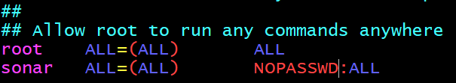

due to some security precautions it’s not a standard practice to run sonar as a root user

so create a new user and provide an access to it

useradd sonar(user sonar added successfully)

to provide sudo access goto

visudo and add sonar there

now we have given the sudo access to username --> sonar

Now we have to run sonarqube s/w with the sonar user

so , we have to change the access

firstly check ls -l

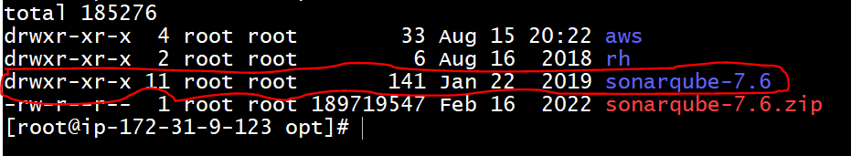

Port changing:



Nexus Repo

